3-2 Enhancement One: Software Design/Engineering
Victor Haro Justiniano
SNHU
Cs499 Computer Science Capstone
Sherri Maciosek
03/28/2026

For this milestone, I selected my Android inventory application as the artifact for the software design and engineering category. I originally created this app in CS 360 as part of my mobile app development coursework. The purpose of the app is to let a user create an account, log in, and manage inventory entries inside the application. I chose this artifact because it gave me a good example of both the front end and back end sides of development working together. It includes user input, screen navigation, SQLite database support, and inventory management, so it felt like a strong piece to include in my ePortfolio.
I chose this artifact for my ePortfolio because it shows several skills that connect directly to software development. It demonstrates my ability to build a functional mobile application, connect the user interface to a database, and create logic that supports the purpose of the app. For this enhancement, I focused on improving the reliability of the inventory screen by preventing duplicate item names from being saved. In the original version, the app could allow the same item to be added more than once, which could make the list harder to manage over time. To improve that, I updated the database and the inventory screen logic so the app checks for an existing item name before saving. I also improved the user feedback by showing a clearer message when a duplicate item is entered instead of only giving a general insert failure. This made the app more dependable and helped strengthen the overall design.
This enhancement aligned best with Course Outcomes 4 and 5. It supported Outcome 4 because I was using practical development techniques to improve the value of the application in a meaningful way. Instead of adding something minor on the surface, I worked on the reliability of how the app handles data. It also supported Outcome 5 because the enhancement focused on protecting the integrity of stored information and reducing a design weakness that could allow repeated or inconsistent entries. After completing the enhancement, I still believe Outcomes 4 and 5 are the best match.
One thing I learned from this process is that front end checks by themselves are not always enough to make an application reliable. It helped me see that the database should also play a role in enforcing important rules. I also learned that even a smaller enhancement can still take testing and troubleshooting to get right. One challenge I ran into during testing was that exact duplicates were being blocked, but the app still treated “Milk” and “milk” as different entries. I went back to the duplicate check in DatabaseHelper.java and looked more closely at how item names were being compared. I found that the original check was catching exact duplicates, but it was still treating names with different capitalization as separate entries. While working through that issue, I also reviewed a Stack Overflow discussion about case insensitive duplicate handling in SQLite, which helped me better understand the cause of the problem and pointed me in the right direction during debugging (Stack Overflow, 2011). In my version, I ended up solving it in two parts. First, I strengthened the table rules by making the item name unique so exact duplicates would not be saved. Then I adjusted the item comparison in the duplicate check so names with different capitalization would be treated more consistently as well. . Overall, this enhancement helped me better understand how small design changes can improve the quality of an app and make the data more reliable over time.

Reference-
Roger. (2017, March 14). Avoid duplicate entries without being case-sensitive? Stack Overflow. https://stackoverflow.com/questions/5664444/avoid-duplicate-entries-without-being-case-sensitive

Images 1: Shows the App UI screen with successfully added Item
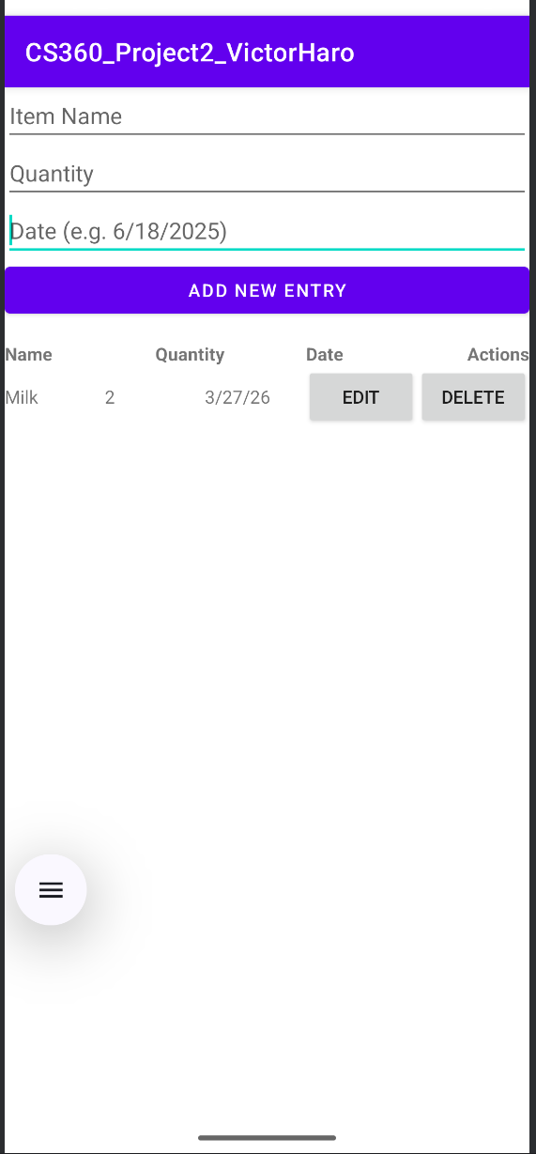
Image 2: Testing done to make sure that same item wasnt allowed to be added and noticed it wasn't case sensitive.
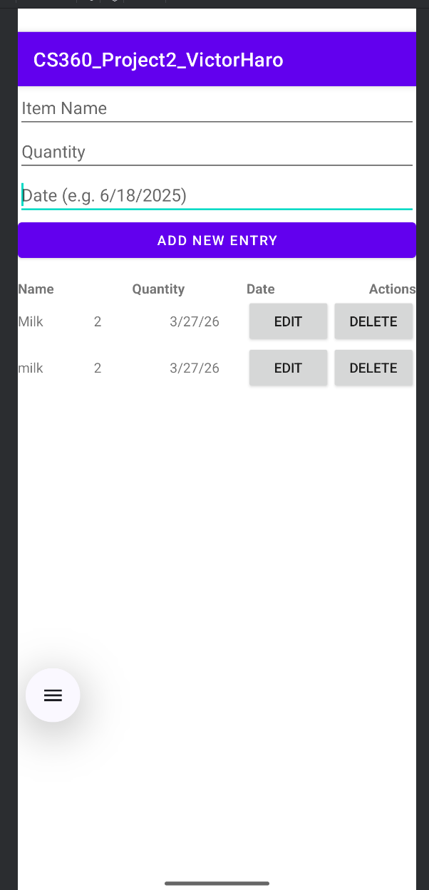

Image 3: Updated items table in DatabaseHelper.java showing the item name set as unique and required fields added to improve data integrity.
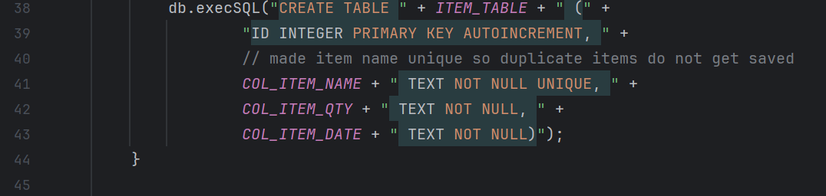
Image 4: First version of the itemExists() method added to check for duplicate item names before saving a new entry.
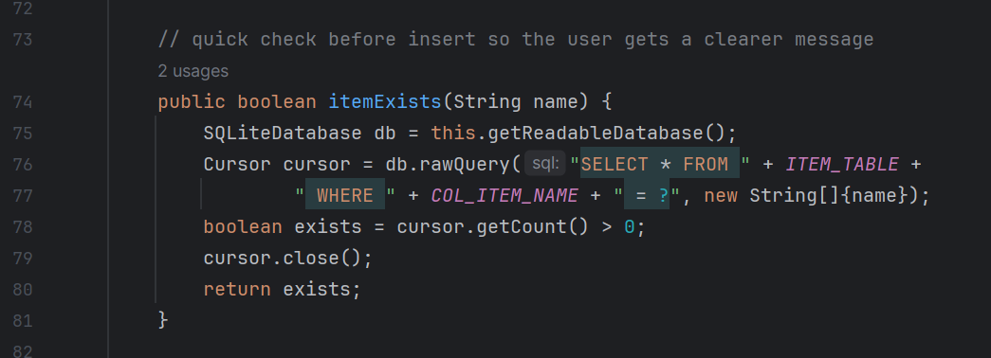
Image 5: Revised itemExists() method showing the case insensitive comparison used to fix the Milk versus milk duplicate issue found during testing.
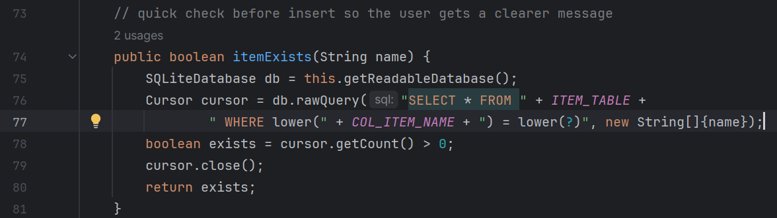

Images 6: I tested the previous entry to which resulted in desired behavior by not allowing item to be added and showed the correct error message.
